Sakshar — Project Overview for Technical Managers
Nov 11, 2026 · @Vaibhav Verma

At a glance
Sakshar is a working web application that reads Indian land records and government forms from a photo or PDF. It pulls out the key details, flags anything it is unsure of, explains the document in plain Hindi, Marathi, Punjabi or English, and answers spoken questions about it. It is complete as a prototype: the full feature set runs end to end on one laptop, 48 automated tests pass, and a live end-to-end check passed every feature.
The problem it solves. Land records (Khatauni, 7/12 Satbara, Jamabandi) and official forms are written in dense administrative language that many owners cannot easily read. Misreading one number, such as a plot number, an area or a loan entry, can cost someone their land rights or a benefit. Sakshar makes these documents understandable without asking the user to trust a black box. Every statement it makes points to the exact text on the page, and uncertain values are flagged for a human to check.
Who it is for. Citizens, field workers and help-desk staff, such as Common Service Centres and legal-aid volunteers, who help people with land and welfare paperwork.
Key fact | Value
Languages | Hindi, Marathi, Punjabi, English (reading, explaining, speaking)
Documents | UP Khatauni, Maharashtra 7/12, Punjab Jamabandi, application forms, certificates, plus a generic fallback
Input | Phone photo, scan or PDF, up to 20 MB and 6 pages
Output | Verified fields, a plain-language explanation with sources, spoken Q&A
Stack | Python, FastAPI, OpenCV, Tesseract, PaddleOCR, OpenAI API, Whisper, IndicTrans2, Parler-TTS
Hardware | One laptop: CPU for reading documents; a 6 GB NVIDIA GPU for voice
Code | ~5,500 lines (3,800 of them application Python) in 66 files, github.com/iwantacrepe/Sakshar
Status | Prototype complete; validated on synthetic documents, not yet on real scans

How it works
Every document goes through six automatic steps, ending in an explanation whose every point links back to the page. Questions, spoken or typed, are answered from that stored result, so the image is processed only once.
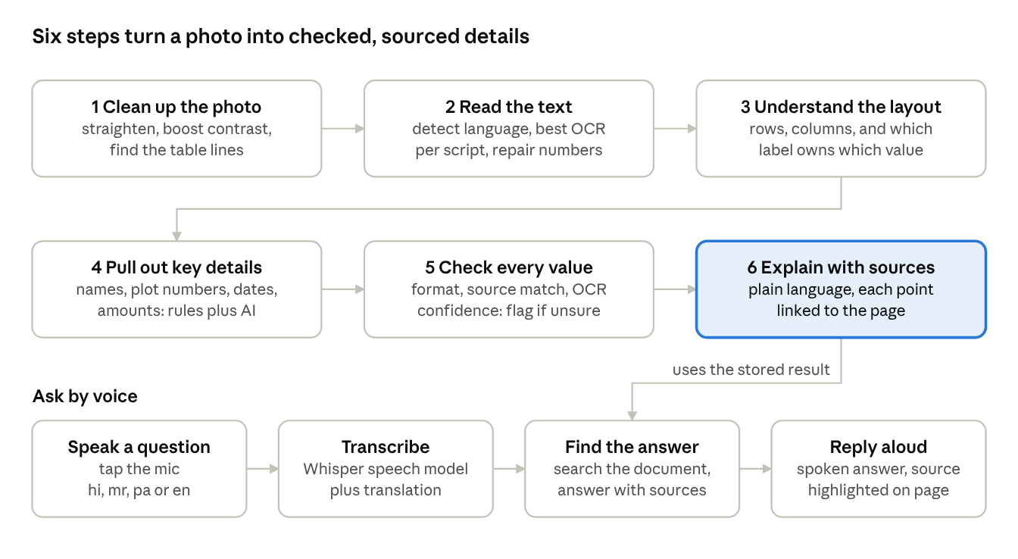
Sakshar pipeline · 6 document steps, 4 voice steps
Between steps 5 and 6, the person sees any flagged values and can confirm or correct them; the explanation then regenerates with the corrected values. Steps 1–5 and the voice models run on the local machine; the explanation and answer text come from the AI service.

Worked example: a Hindi Khatauni, start to finish
This follows one real run of the Hindi sample, a UP land record photographed slightly crooked, with a purple stamp and one smudged digit. It took about 7 seconds from upload to verified fields. Each step below shows what the system actually produced.
1. Upload. The user drops hi_khatauni.png on the home page and picks "Explain in: Same as document". The page switches to a live progress list that ticks through the stages as they finish.
2. Clean up the image. The photo is tilted. Sakshar measures the tilt from the table's printed lines: +3.5°, which matches the 3.5° it was rotated by. It straightens the colour image, so the stamp stays purple in the viewer, and builds two cleaned copies, one for each OCR engine.
3. Work out the language. Unicode counts and marker words identify Hindi, Devanagari script. For example, खसरा and तहसील point to Hindi, while आहे would have pointed to Marathi.
4. Read the text. Tesseract's Hindi model reads the page, and an English-only pass corrects the numbers it misreads. Before the correction, 00127 came out as 0027 and 214 was lost; after it, both are right. PaddleOCR finds any lines Tesseract skipped. Result: 31 text blocks, each with a confidence score.
5. Understand the layout. The printed table lines become rows and columns. The header "खसरा संख्या" (plot number) is linked to the cell beneath it, "214". The two-line owner cell, "राम प्रसाद पुत्र श्याम लाल / निवासी रामपुर कलां", stays together as one value.
6. Identify the document. Keywords like खतौनी, खसरा and फसली classify it as a UP Khatauni, with 93% confidence.
7. Extract the key details. Rules for the Khatauni schema, cross-checked by the LLM, give:
Field | Value | Status
Owners | राम प्रसाद …; सीता देवी … | OK
Father / husband | श्याम लाल; राम प्रसाद | OK
Khata number | 00127 | OK
Khasra (plot) number | 214 | OK
Area | … हेक्टेयर | Flagged: smudged digit, OCR confidence 48%
Village | रामपुर कलां | Flagged: OCR confidence 74% (threshold 75%)
Tehsil / District | नगीना / बिजनौर | OK
Mutation order date | 12/03/2023 | OK
Land revenue | ₹45.00 | OK
Aadhaar | XXXX-XXXX-9005 | OK: checksum valid; masked before anything leaves the machine
8. Verify. Each value is checked against four tests:
- Does it parse as a date, amount or area?
- Is it actually present in the text it came from?
- Was the OCR confident?
- Do the two extractors agree?
The two flagged fields show on screen as amber cards with a crop of the original image, so the person can confirm or correct them.
9. Explain. The LLM writes 4–10 short points in Hindi. Each cites the text blocks it came from, for example "खसरा संख्या 214 है।", tagged with the id of the block holding "214". A checker then confirms that every number in each point appears in the cited text. Clicking a point highlights its source on the page image.
10. Ask by voice. The user taps the mic and asks "मेरी ज़मीन का खसरा नंबर क्या है?" ("What is my land's khasra number?"):
- Whisper transcribes it.
- IndicTrans2 translates it as "What is the Khasra number of my land?". Without a fix, "खसरा" was first translated as "measles", its other meaning in Hindi.
- Sakshar finds the answer in the document.
- It replies aloud: "आपकी खसरा संख्या दो एक चार है…" ("Your khasra number is two-one-four…"), with the plot number spelled digit by digit, and highlights the source on the page.

Why the answers can be trusted
The core design principle: the system never states a fact it cannot point to on the page. Five safeguards enforce this, and each is covered by automated tests.
Safeguard | What it does | Why it matters
Source citations | Every explanation point and every answer carries the ids of the text blocks it relies on; clicking it highlights them on the image | The user can check any claim in one click
Grounding check | Code, not the AI, checks that every number, date and amount in a statement appears in its cited text. A wrong citation is repaired; a value found nowhere marks the statement "Not verified"; an unsupported numeric claim is dropped | Stops the AI from inventing or garbling plot numbers, areas or amounts
Review flags | A field is flagged when OCR confidence is low, a validator fails (bad date, impossible amount, Aadhaar checksum), the value isn't in its source, or two extractors disagree. Legal and financial fields have a stricter bar (85% vs 75%) | Uncertainty is shown to the person instead of hidden; they confirm or correct, and the explanation regenerates
Two independent extractors | Rule-based extraction and AI extraction run separately; agreement is recorded, disagreement is flagged | One method catches the other's mistakes
Privacy by default | Aadhaar numbers are validated locally and masked (XXXX-XXXX-1234) before any text is sent to the AI service or saved; raw provider error text is never shown in the UI | Sensitive IDs never leave the machine or sit on disk
In practice: on all four sample documents, every deliberately smudged value was flagged, and no correctly read value failed validation.

Technology choices
Each component was chosen, and in several cases changed, because of how it measured on the actual documents and hardware.
Area | Choice | Reason
Web app | Python FastAPI + server-rendered pages (HTMX) | One language for the whole project; live progress via server-sent events; no separate front-end build
Image cleanup | OpenCV | Straightening, contrast and table-line detection
Reading Hindi / Marathi / Punjabi | Tesseract 5 | Clearly the most accurate on printed Devanagari and Gurmukhi in head-to-head tests. PaddleOCR's Devanagari model dropped spaces and reported false high confidence; Paddle has no Punjabi model
Reading English, finding text lines | PaddleOCR 3 (mobile models) | Strong on English; its line detector finds text Tesseract misses. The mobile models cut processing from ~50 s to 8 s per page
Explanations and answers | OpenAI API (gpt-4o-mini, configurable) with structured outputs | Reliable JSON with citations. Any OpenAI-compatible endpoint, including a self-hosted one, can be dropped in
Speech to text | Whisper large-v3-turbo | The smaller Whisper model produced unusable Punjabi; turbo transcribes all three languages well
Translation | IndicTrans2 (AI4Bharat) | Purpose-built for Indian languages, runs locally
Text to speech | Indic Parler-TTS (AI4Bharat) | Natural Hindi, Marathi and Punjabi voices, runs locally
Storage | SQLite | Zero setup; enough for a single-machine deployment
Environment | Conda (conda-forge), Python 3.11 | Reproducible install of a heavy ML stack on Windows; version pins resolve real conflicts between the OCR and voice libraries
Everything except the explanation and answer calls runs on the local machine.

Quality and testing status
All 48 automated tests pass, and a final live end-to-end check of the running app passed every feature listed below.
Automated tests (48) cover:
- image straightening accuracy;
- language detection;
- number, date and amount parsing in all four languages;
- the Aadhaar checksum and masking;
- table layout;
- every review rule;
- the citation checker;
- search that tolerates OCR typos;
- a full upload-to-answer flow with the AI mocked;
- one regression test for each serious bug found during development.
Live end-to-end check against the running server:
- ☒ Upload from the browser form, including 4 documents at once and a PDF
- ☒ Live progress stream through all stages
- ☒ Each document gets the correct language and type
- ☒ Document page with image, highlight overlay, extracted details and mic button
- ☒ Review: confirm and correct a flagged value; the explanation refreshes
- ☒ Voice questions in Hindi, Marathi and Punjabi transcribed correctly from browser-format audio
- ☒ Spoken answers ("Listen") in all three languages
- ☒ Typed questions
- ☒ Bad files, empty audio and unknown documents rejected cleanly
- ☒ App works offline apart from the AI calls (front-end libraries bundled)
Test documents. Four synthetic records were generated, one per language: a UP Khatauni, a Maharashtra 7/12, a Punjab Jamabandi and an English application. Each was given real-world damage: a 3.5° tilt, an ink stamp over a date, uneven lighting, noise and one smudged digit.

Performance and hardware
A one-page document goes from upload to verified details in 7–20 seconds on a laptop CPU. A voice question is transcribed in 2–3 seconds. The spoken reply is the slowest step, at 8–25 seconds.
Step | Typical time
Read and verify a Hindi or Marathi page | 7–9 s
Read and verify a Punjabi page (more re-reads) | 13–20 s
Read and verify an English page | 8 s
Transcribe a voice question | 2–3 s
Translate a question | under 1 s
Generate a spoken reply | 8–25 s
First voice request after start-up (models load) | 1–1.5 min, once
Hardware. Development used a laptop with an NVIDIA RTX 3060 (6 GB). The voice models stay loaded together and use 3.7 GB of GPU memory. Document reading runs on the CPU, so the app also works without a GPU: voice is then slower, or can be switched off.
Demo tip. Ask one warm-up question after starting the server, so the first live question is fast.

Key engineering challenges solved
Thirty-two problems surfaced while running the system on real models and images; all are fixed, and the detailed log is in the Technical Design & Engineering Reference. These eight had the biggest effect on quality or reliability:
Challenge | Impact if unsolved | Solution
The obvious OCR model for Hindi was confidently wrong (no spaces, broken letters, 95% confidence) | Garbled text the system couldn't even flag | Measured both engines head to head; switched Indian scripts to Tesseract and kept PaddleOCR for line finding and English
Hindi and Marathi OCR misread ordinary numbers (00127 → 0027, 214 lost) | Wrong plot and account numbers, the most critical values | A second number-only reading pass that repairs digits without touching words
Table labels sit in headers, values in cells below | Fields filled with the wrong numbers, e.g. Aadhaar digits as the khata number | Detected the printed table lines to reconstruct rows and columns, then paired each header with its own column
A slight leftover tilt merged neighbouring table rows | Values assigned to the wrong row | Measured skew from the table's straight lines instead of the text: now exact (3.50°) on every sample
"खसरा" (plot number) also means "measles" in Hindi; the translator chose measles | Voice questions misunderstood | Domain terms are protected before translation
Spoken numbers came out unintelligible | Users couldn't hear their plot number | Numbers are spelled digit by digit in the target language
Punjabi speech recognition returned gibberish with the small model | Punjabi voice unusable | Upgraded to Whisper large-v3-turbo with a script-correction step
Server-only crashes: the OCR library failed under concurrency, and the voice library failed after OCR had loaded | App failures that standalone testing missed | All OCR-library work runs on one dedicated thread; libraries load in a safe order. Both are covered by regression tests

Risks, limitations and next steps
The main risk is that accuracy has been proven only on synthetic printed documents. The highest-value next step is a pilot on real scanned records, measuring field-level accuracy.
Risk / limitation | Effect | Mitigation today
Not yet tested on real scans | Real-world accuracy unknown | Synthetic samples include realistic damage; review flags catch low-confidence values
Handwriting not supported | Older handwritten registers will read poorly | Low OCR confidence triggers review
A stamp fully covering a value | That field may be missing rather than flagged | Missing required fields are reported in the progress view
Speech auto-detection mistakes Marathi and Punjabi for Hindi | Wrong transcript if the language isn't set | The app uses the language selected on the page
Spoken replies take 8–25 s | Slower conversation | Audio is cached; text answer shows first
Single-machine design, no login | Not ready for multi-user hosting | Intended for local or help-desk use
Explanations depend on an external AI service | Needs internet and an API key | Any compatible endpoint, including self-hosted, can be configured; all other features work without it

